
SMART STAR EXAMINATIONS BOARD
BEGINNING OF TERM I EXAMINATION – 2024
P.3 READING
Time Allowed: 2hours 15minutes
Name: _____________________________________________________________
School: ___________________________________________________________
- Use the sounds to form words.
sm: _____________________ sh: _____________________
dr: ______________________ sw: _____________________
st: _______________________ so:
- Fill in the gaps with the missing sounds.
dr ___ss kn ___fe t _____ ____th
d __sk be ____ _____ bo _____ _____
- Write the sentences correctly.
- taking tea She is.
_____________________________________________________
- mother cooking food is.
______________________________________________________
- eating is he.
______________________________________________________
- Sarah is name her.
______________________________________________________
- going to school Juma is
______________________________________________________
- Read correctly.
- Policeman, nun, tailor

- The policeman keeps law and order.
- I write in my book with a pencil
- Write the correct word in the space provided.

- Mr. Mukasa lived in a small ________________.( hut hat)
- My sister went _____________ the market. (two, to)
- I saw a big snake in a ___________________(hole, whole)
- We ________________ soap from the shop. (by , buy)
- I _______________ in my book with a pen. (right, write)
- Match correctly.
Policeman grows crops.
A farmer preaches in church.
Toilet cleaner calf
A cow keeps law and order.
Pastor cleans the toilets.
- Read the story and answer questions that follow in full sentences.
MR. KAYONGO’S FARM
Mr. Kayongo is a farmer. He has a big farm of thirty three cows, twelve goats and eight sheep. He milks the cows every day and sells milk to different people.
He puts the milk in very clean cans and people like it very much.
Questions:
- Who has a big farm?
______________________________________________________

- How many goats are on his farm?
______________________________________________________
- Draw and name two animals on Kayongo’s farm.
- What is the title of the story?
______________________________________________________
- Copy and write.

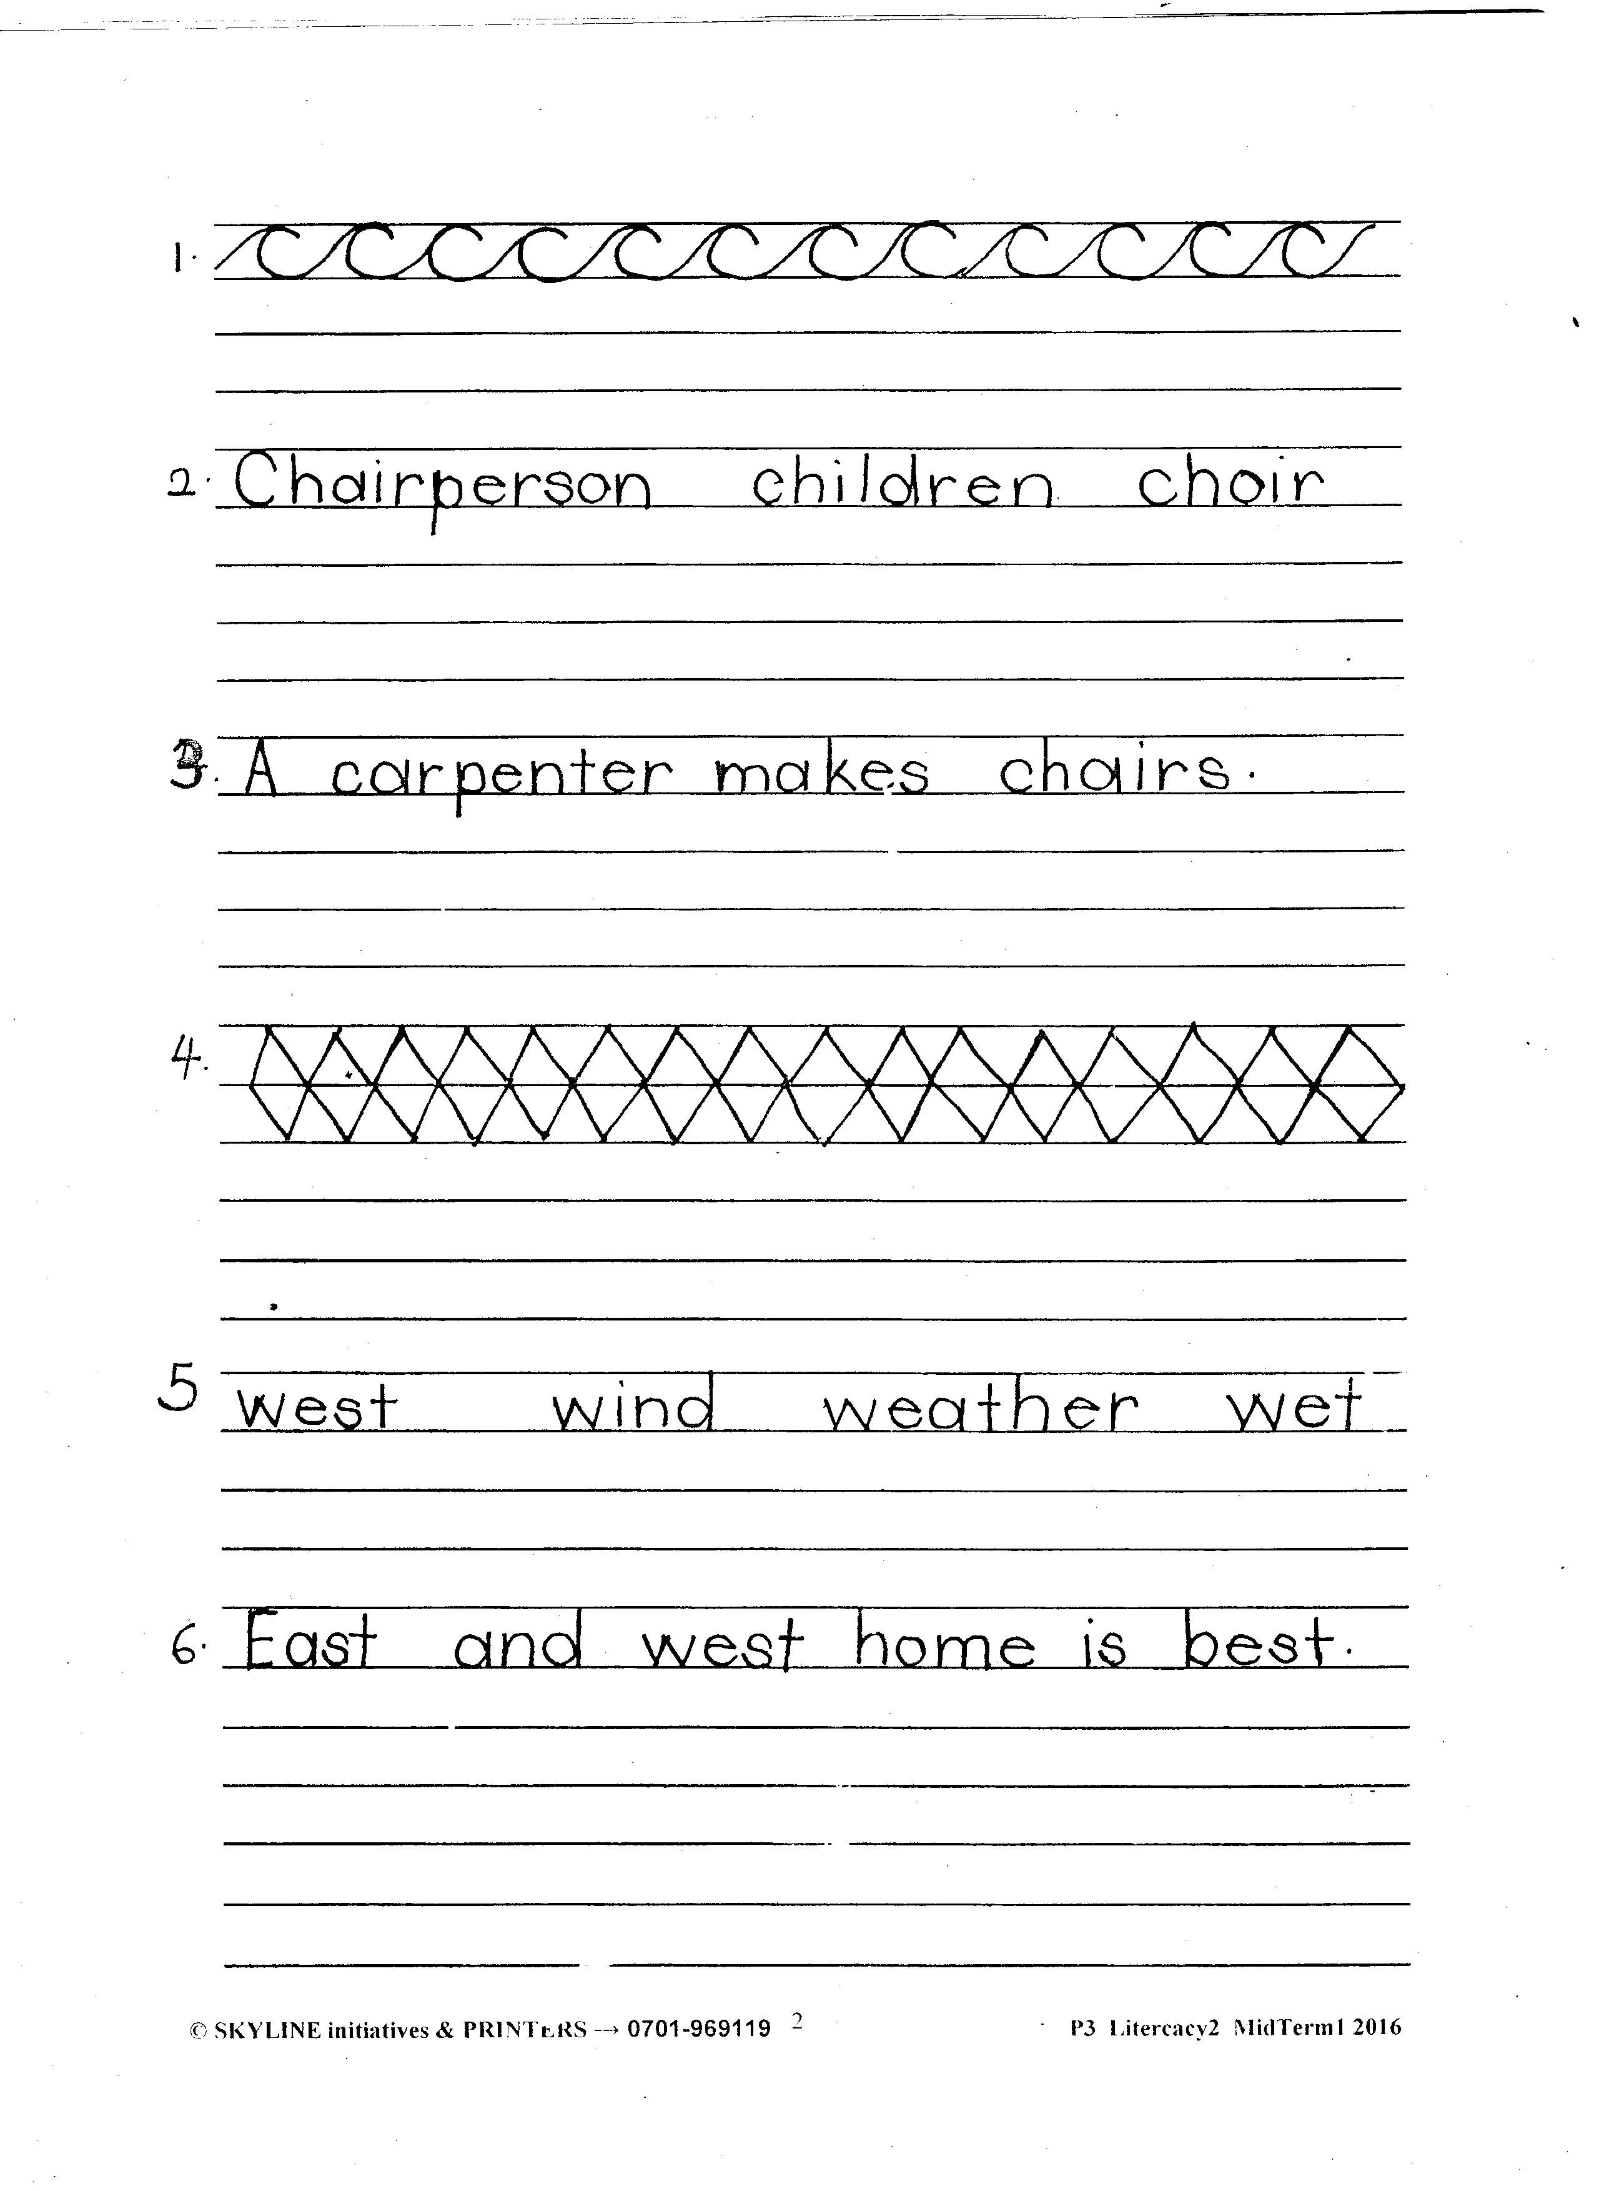

- Copy and write.
END

